Wiring Diagram

Thomas Schenk

Contents

Introduction 3

Problem 4

Solution 5

Product 6

## Introduction

The robot received at the start of this semester was, to say it shortly, in shambles. We received parts only. Some parts already fit, some didn’t.

## Problem

With a big pile of parts at our disposal, we knew how to put them together. What was however not immediately clear, was how to connect them properly. No diagrams or wiring schemes were present. Some wires seemed to be properly connected already, while some seemed way off to our logic. All this untrusty information resulted in a big confusion.

## Solution

Make one standardized wiring schematic which clarified both our intentions and our way of working.

## Progress

To effectively create a nice wiring scheme, firstly we gathered all the information possible about the hardware we were going to use.

For example, what are the number of in and outputs on the motor controllers?

With these in mind, we could start to create the diagram. Which was done rather quickly, due to the way we set it up beforehand.

## Product

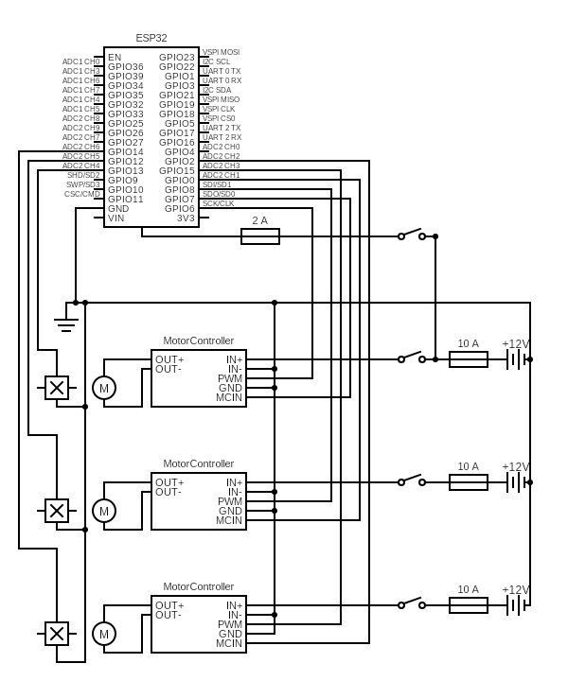

*Note: Microcontroller as of now is abstract, no pinouts have been determined yet.*